***CLOUD COMPUTING:***

A style of computing in which scalable and elastic IT-enabled capabilities are delivered as a service using internet technologies.

**Scalable and Elastic:**

**On premises:**

* On premises servers hardware,softwares,networking should be done on their own.
* Requires huge spaces , teams and support.
* Can be beneficial only if the work and use cases is stable or constant .
* Adding or removing servers takes longer time and several maintainces.

**On cloud:**

* Efficient when the traffic is unstable or in different trends.
* Does not require to maintain servers and specialized team.
* Saving costs in a big scale.
* Requires very few duration to add or remove servers.

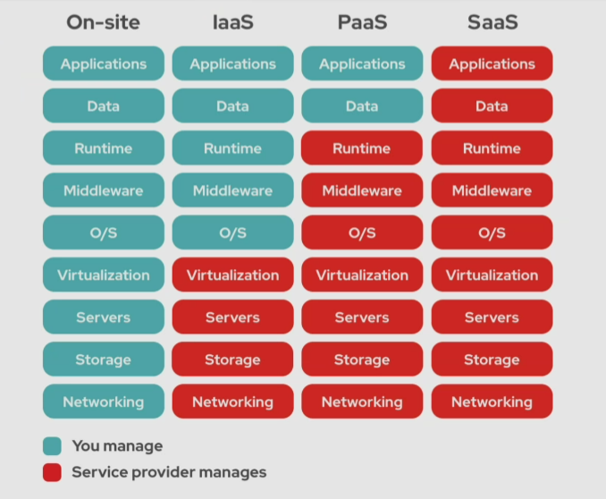

**LOAD BALANCER:**

